MED D - Reading Prior Call/Activity Notes (PeopleSafe)

Overview
Why Reading Notes is Important
Making a Call More Conversational
Examples of Where Referring to Prior Notes Are Critical
Outbound Campaigns
Beneficiary has a request
Repeated Calls
Viewing Comments
Viewing RM Task Notes via View Comments
Viewing RM Task Notes via View Activity
Related Documents

Overview
Reading and writing detailed notes is very important in providing 5-Star Customer Service, and first call resolution reduces the number of calls our beneficiaries place to us, which then reduces their frustration with their Medicare Prescription Drug Plan and the eventual number of CTMs.
Although it might not be crucial to read all notes or activities, every effort should be used to not only ask beneficiaries if they had called us recently about the same issue, but should always be a standard practice to look for notes to be well informed so you can provide great Customer Service.
Documentation in PeopleSafe is not only important for audits and CMS reviews, but it is an invaluable tool for assisting the caller.

The primary errors when CCRs handle calls are directly linked to not properly researching a caller’s issue, both in the comments and notes left in the account and by not properly accessing all the systems available to the CCR to help them assist the beneficiary.

Proper documentation in PeopleSafe will provide you the following information to assist on a call:
- Who called?
- What the caller is calling about / What the issue is
- Where the problem exists (Example: Mail order, point of sale, etc.)
- When the issue occurred or is anticipated (in the past or future date)
- Why is it an issue for the beneficiary / Why it should be resolved

Top of the Document

Why Reading Notes is Important
So why is checking activities and notes so vital?

It is a strong possibility that the person who is calling is not calling for the first time because:
- Their issue was not previously resolved
- Received a communication that caused them to call (letter/received a call)
- Were advised to obtain additional information

For this reason, you should always assume that there are notes in their account that can assist you to be prepared so you can show the beneficiary that you are there to support them with their issue.

After looking at the notes, you will discover several possibilities including but not limited to:
- Directions on what to do with the customer if they call in
  - Warm transfer them
  - Advise them of something
- A history of calls related to the same issue
  - Allows you to avoid duplicating efforts
  - Determine what would be the next step to take or questions to ask to help dig deeper
- Outbound calls made on specific information to share with beneficiary.

By looking at the notes, you can proactively address the issue that the beneficiary is facing without requiring them to spend time re-explaining the history all over again.

Top of the Document

Making a Call More Conversational
A major complaint for Grievances from beneficiary frustration is repeatedly put on hold for long periods of time while CCRs conduct “research” or say “let me look into your account”. How often have you called into somewhere and been put on hold, not a fun experience is it?
The same applies to our beneficiaries who just want their issue resolved. This is even worse when their first conversation after authenticating is putting them on hold.

AVOID putting them on hold.

After you complete your authentication process and the caller asks their question, consider saying:
- “I heard you say you called before, let me take a look at your account to be better aware of your recent activity”
- “Have you called us about this issue before?”
- “Let me look into your account to look into any prior calls or activities that will equip me to better serve you.”

Once you are in the notes, you can easily transition into:
- “I see in your account that you’ve called recently about ___________”
- “I see that you were recently called by the Late to Fill team. Let me warm transfer you to them so they can assist you.”
- “I noticed that we recently sent you some ______________”

Keep the flow of communication going to demonstrate your 5-Star Customer Service and assisting the beneficiary so they will not have to call back again for that same issue and ensure you recap, so that you ensure you covered everything they need.

Top of the Document

Examples of Where Referring to Prior Notes Are Critical
Nobody wants to give inaccurate information, but regrettably, it has been happening over and over again. Why? Because the person handling the call did not refer to prior notes to know there was something particular that needed to be shared or the way to properly handle the issue.

Here are a few examples of different recent categories where this has occurred repeatedly.

Outbound Campaigns

Often, beneficiaries call in saying they received a voice mail from someone saying they represented CVS and were trying to get more information on why they called.
An example of this is the Outbound calls regarding Late to Fill (LTF) which is a program conducted by the LTF team composed of pharmacists and agents conducting outbound calls to beneficiaries who are identified as having a late to fill medication including Oral, Diabetic, Cholesterol-lower, Blood Pressure, etc.

Regrettably, in some cases the CCR tells the beneficiary that it is a potential scam, or that they are unaware of that program and unable to help.
One situation would find the CCR leaving a comment where they advised the beneficiary that the phone call could have been a potential scam, because the beneficiary isn’t one available in the CVS Caremark Outbound Phone Numbers Displaying on Caller ID work instruction. If the CCR had taken the time to view the comments, they would have realized that they should transfer to the Late to Fill team. Instead, their remarks appear right above the one instructing them on the proper steps.

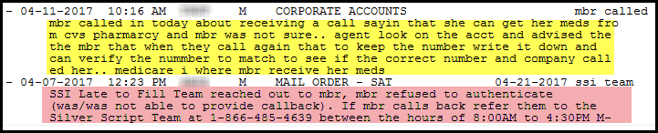
Figure A

Here again is another example. As you can see, the comments left by the Left to Fill team is always the same.
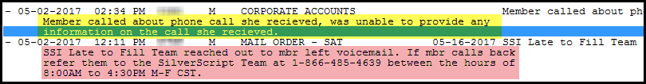
Figure B

Beneficiary has a request

Beneficiaries may call in to request updates to their accounts, overrides or requesting to disenroll.

Reviewing the notes will provide:
- Whether or not ALL the options are provided as required by CMS
- Information that was provided and if additional steps are expected
- Whether prior calls were made
- If inaccurate information was given

A prime example is one of the major drivers of CTMs – Disenrollment. In this situation we see several CCRs requesting the same action (for example submitting an RM task to send them a disenrollment form), which could be avoided by looking into what was already sent and confirming receipt.
Possible statements could be:
- “I see here that on a previous call, you requested a disenrollment form. Did you receive that form that was sent out, and do you have any questions about the information it requires?”
- “I can provide you additional options if we are having difficulty getting that form sent out to you, or if you have not received it yet.”
- “I see a form was requested for you, but we have not yet received it back. From what you're telling me, you seem to qualify for an SEP, so let's discuss all of the options available to you.”
- “I see an activity was set up to send you the disenrollment form. Let me walk through all the options again, so maybe we find one that might work better for you.”
- “I see a form was scheduled to be sent to you. Did you receive it?” If they say no, follow up “Can you advise me of your address so I can confirm we have the correct one on file.”
- “I see a form was scheduled to be sent to you but we have no record the form has been received from you. I see you do qualify for an SEP, so to avoid any further delays let me tell you all the options so we can find one that may work quicker for you.”

Although we never want to lose a beneficiary, we still need to provide 5-Star Customer Service to everyone who calls in.

Repeated Calls

Either through comments by the caller, or through proper probing into the issue, you can uncover that they have made repeated attempts to get someone to properly assist them.
- “I have called several times and nobody seems to be able to help”
- “This is the 3rd time this month I’ve called”
- Asking the beneficiary
  - “Is this the first time you’ve called about this issue?”
  - “Have you contacted us about this before?

Viewing Comments

Follow the Work Instruction MED D - Call Documentation Including Viewing and Adding Comments in PeopleSafe on how to view comments.
- Viewing Member Level Comments
- Viewing Order Level Comments
- Viewing Prescription Level Comments
- Viewing Archived Comments

In addition, use tools such as LINKs, FileNet and One-Click to view appropriate letters when they indicate they received a letter. By understanding what was communicated, you can then follow the proper procedures to properly assist them.

Top of the Document

Viewing RM Task Notes via View Comments

Perform the steps below:
Step | Action
1 | Select the View Comments button at bottom of Main Screen Tab in PeopleSafe.  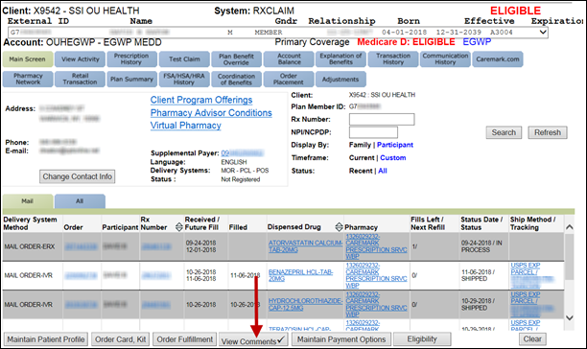  Result: Comments screen will display.  Note: A pop-up box may display if there are more comments on the account. Select OK.  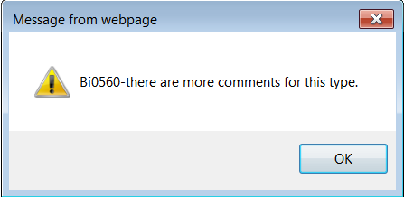
2 | Locate the task to view.  Note: If unable to locate the Task, you can search by date. The Date Range needs to be within a 3 month time frame. Enter the start – end date, then click Search.  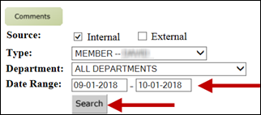
3 | Click the task to highlight it.
4 | Click the View Task Details button.  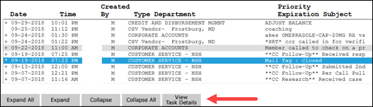  Result: The Task Attributes View Mode Screen will display.
5 | Click the down arrow inside the Notes History box to view the original notes of the RM Task.  Note: Each comment will be separated by the date it was entered along with the agent’s username.  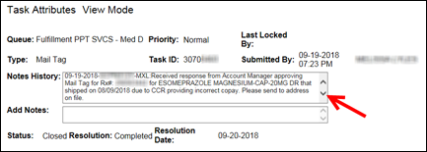
6 | Click the up arrow to scroll back to the beginning of the notes to view the results of the RM Task.  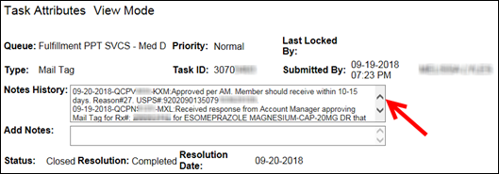  Example: The Results of the task above states the Mail Tag was sent via USPS and the beneficiary should receive it within 10-15 days from 09/20/2018.
7 | Click the Close button to return to the Comments Screen.

Top of the Document

Viewing RM Task Notes via View Activity

Perform the steps below:
Step | Action
1 | Select the View Activity Tab on the Main Screen Tab in PeopleSafe.  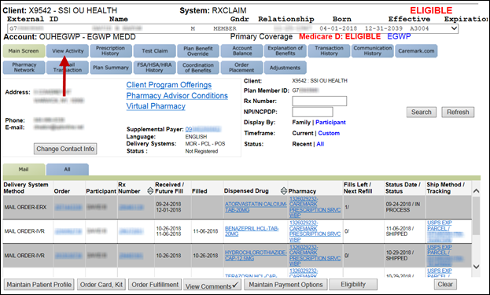
2 | On the View Activity Screen, locate the Tasks Category then scroll down to applicable RM Task.  Note:  - The status of the task will appear on the right side it.  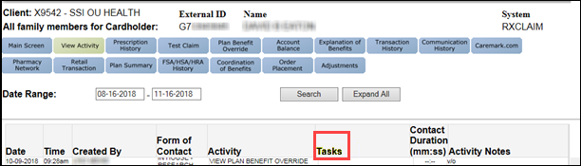
3 | Click the Task Type, link in order to access the task details.  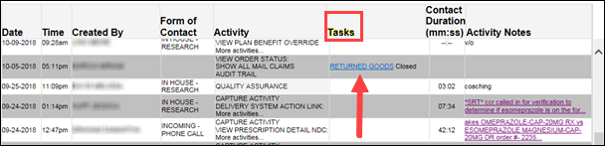  Result: The Task Details Screen will display.
4 | Scroll down in the Notes History section to view the original RM task request, if applicable.  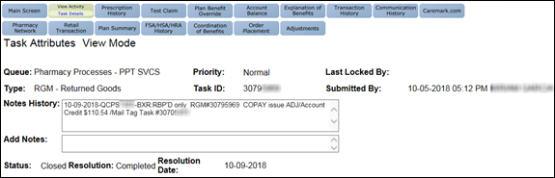  Example: The Returned Goods Rm Task above states that the medication was received back and a credit of $110.54 was added to the beneficiary account on 10/09/2018.
5 | Scroll down and select the Back button to return to the View Activity screen.

Top of the Document

Related Documents
Parent SOP: CALL-0048: Medicare Part D Customer Care Call Center Requirements-CVS Caremark Part D Services, L.L.C.
Abbreviations/Definitions: Abbreviations / Definitions

Top of the Document

Not To Be Reproduced Or Disclosed to Others Without Prior Written Approval
ELECTRONIC DATA = OFFICIAL VERSION - PAPER COPY = INFORMATIONAL ONLY

